

SAATHI- Your Fitness Companion

**Aadit Shah, Rishne Jain, Vibhav Singh, Neer Mehta, Ishaan Makharia, Reetu Jain, Vikramjeet Singh, Shekhar Jain**

On My Own Technology Mumbai, MH, India

***Abstract* -*Our project is designed for elderly to stay active. An insistent problem that they face is a lack of regular physical exercise which is induced by lack of motivation. In our research we found two h: that many of them struggled to use technology and preferred to exercise in groups which made them feel more satisfied and happy while exercising and also motivates them to make a continuous effort. Keeping these in mind, our app works by addressing their loneliness and getting company to exercise with. Since they have an apathy in using technology we have strived to keep our design as simple as possible with our entire premise being simple and social.***

***This is achieved with the following technology:***

***To address these problems, we have created an exercise wristband which measures steps walked and a mobile app which displays them.  The app, which is connected to the band via bluetooth, displays the steps, sets a goal and also allows the user to form exercise groups where people can exercise together. The band not only measures the steps but also indicates progress towards the daily goal.***

***This app is as simple as can be, with few pages and large, clear icons to use. Using the band is also convenient as the user only has to switch and strap the band on to get it working.***

***To connect with other Saathi users, one needs to only select a group and can then access their data as well. This acts as a source of both competition and inspiration, motivating the elderly to stay active as well.***

***These features generate a source of motivation, togetherness and independence which is novel to our product.***

***Keywords*- *Elderly Care, Exercise, Activity Monitoring, Fitness Tracker, Health, Social Communication, Wearable Device, Geriatic Care***



# Introduction:

# Exercise is any bodily activity that helps you enhance or maintain your physical fitness and overall health and fitness. It is vital for any human being, aspiring to stay healthy and trying to prevent any unnecessary illnesses. Inactivity can cause higher risk of heart problems, due to higher cholesterol and fat quantities, obesity, increased risk of diabetes and cancers. Exercising also helps maintain strong muscles, joints and bones and helps to keep you in a better mood.

# According to WHO, the World Health Organisation, senior citizens are most prone to back and neck pain, osteoarthritis (the wearing down of joints), pulmonary diseases (affects the lungs), diabetes and depression. Physical activity tackles almost all of these issues, making sure even the elderly can stay healthy and have a happy life. Apart from helping with all these health issues it also solves one of the biggest problems that people over 60 years of age face. According to research(What to Know About Living Alone After 60, 2021), over a quarter of adults over 65 are considered to be having some form of social isolation. Loneliness(Rey, 2020).

# According to recent research (Global Health Research and Policy, Wu, 2020), social isolation and loneliness are major risk factors that have been linked with poor physical and mental health status. Social isolation has been associated with an approximately 50% increased risk of developing dementia, a 29% increased risk of incident coronary heart disease and a 32% increased risk of strokes. Social isolation in the elderly also causes lack of motivation as they aren’t connected to the outside world and are falsely satisfied even if they don’t accomplish anything, because there is nobody to share anything with. A simple solution to this for younger generations would be connecting with people through social media platforms and other technology, or to download a fitness app and follow a fitness workout for a specific time. However, the elderly have lots of trouble using technology.

# According to a survey (Why do many seniors have trouble using technology? , 2021, July 16), 77% of senior citizens said that they would require assistance were they to learn how to use a smartphone or a tablet.

Today, there are an increasing number of negative consequences and health risks for the elderly who have inactive lifestyles.

**1.** **Coronary Heart Diseases**

A coronary heart disease is the blockage of the coronary arteries, the blood vessels that supply blood to the heart itself. This happens when unwanted fat forms layers inside the coronary arteries.

**2.**  **High Blood Pressure**

It is when your heart starts working harder and faster and beating overtime. This can also lead to heart attacks and strokes.

**3.** **Type 2 Diabetes**

It refers to a high level of blood sugar(glucose). This happens when you don’t utilise the glucose and it doesn’t go to the cells and stays in the blood.

**4.** **Osteoporosis**

Osteoporosis is a disease that thins and weakens the bones. It is usually caused when degrading bones aren’t used regularly in a person’s body.

**5. Depression**

Depression can cause feeling sad or "empty", loss of interest in favorite activities, overeating, or not wanting to eat at all, not being able to sleep, or sleeping too much, feeling very tired, feeling hopeless, irritable, anxious, or guilty, aches or pains, headaches, cramps, or digestive problems and thoughts of death or [suicide](https://medlineplus.gov/suicide.html).

# To help solve these three problems, lack of motivation through loneliness, maintaining fitness and being able to use technology, we developed Saathi. Saathi has two main components: a band which latches onto your wrist just like a watch and an app which helps you connect with people who have similar exercise needs, activity type and location to you.

From our interviews, we learned that the major form of exercise for them is walking and thus keeping these factors in mind, we saw the opportunity to design our invention.

We have also noticed that these existing problems have been further exacerbated by the pandemic as the psychiatrist we interviewed stated that the mental impact of the pandemic is as severe as the physical impact. Amongst elderly, who are more prone to the virus, it has led to limited social interaction which carries forward into loneliness and possibly depression.

We found the opportunity to design our innovation in this space as we found that there are almost no products designed to motivate elderly to stay active.There are numerous apps and bands that monitor health parameters like blood pressure and blood sugar etc. There are some equipment to aid exercise for the elderly but there are no products designed to keep them motivated through other human interactions.  We strongly believe that if we address motivation to stay active, we will be able to aid our target group of elderly in leading a healthy lifestyle.

We are focusing on how we might design a solution that is SIMPLE and SOCIAL to motivate the elderly. Our innovation design is a wrist band named SAATHI (companion in Hindi), paired with a mobile app. For simplicity, the wristband has a single primary feature: a band that changes color once the fitness goal for the day is met. The app on the phone  has features such as:

A) personalized fitness goals

B) access to join small fitness groups- like a local, neighbourhood group for walks and an           online group with a similar skill level

C) A record of  the individual’s fitness activity

The color change on the wristband from red to green will act like a nudge for the elderly to perform daily activities.. The app interaction is minimised to set goals, join groups, and keep records.

While designing our band and app our main focus has been on keeping it as simple and effortless as possible so that no one faces any difficulties while navigating through either product. We believe that the simpler our product is to use the more likely older people are to not only use it but also benefit from it. We have included features such as large icons and limitations on the number of groups one can join so that people don’t join too many groups and get confused, few onboarding steps, no passwords to remember and uncluttered pages on the app.Furthermore, we have also put clear indications on the band to provide information about their daily goal  by icons that light up. Lastly, we have tried to exempt all the unnecessary information that could cause any confusion in decision making.

### We are using the philosophy of keeping minimal features on the app to make it easy for elderly to use the app.

# LITERATURE REVIEW

The benefits to users who purchase our product are varied and collectively address our problem statement. One key impact is **Independent Monitoring**. Elderly citizens can set goals and challenge themselves, review past exercise, and Saathi gives them full control over their fitness in a hassle-free manner. Such independence acts as a motivator and  makes them conscious about their fitness, leading to self-awareness. Potential users we interviewed shared this perspective and a psychiatrist we contacted also mentioned the numerous mental benefits of Independent Monitoring.

Additionally, our product provides a constant source of **Motivation**, via various “nudges” to exercise. These include, the band turning from red to green, challenging and monitoring oneself, and using group exercises as a source of both competition and inspiration. Consistency is key to any exercise routine and the sources of motivation, external and internal will maintain the rigour. The users we contacted stated that they were discouraged from both internal laziness to not exercise and external discouragement from others who believe they are too old for exercise. Our social aspect intends to flip this external discouragement to external encouragement. The physiologists we talked to mentioned that demotivation is the most common roadblock preventing exercise and Saathi aims to solve that.

Furthermore, the product  achieves **Togetherness**. From the people we interviewed, there was absolute certainty that companions enliven mundane exercise. Saathi allows its users to not only form groups amongst friends but also with new people. This is especially important in combating loneliness as a survey in Delhi of 15000+  seniors revealed that almost half of them suffered from the same. This has been further amplified due to the Covid-19 pandemic as stated by Dr Rachana of the NHS(UK).

For these three aspects, we want a large volume of impact. To achieve this, we intend to keep our prices low, around half the price of similar products, that will give us a sizeable customer base and a greater reach.

These aspects all point to a better quality and quantity of exercise which has been confirmed by the CDC and WHO to lead to fewer diseases, peace of mind and a longer lifespan. Hence, exercise kills two birds(mental and physical health) with one stone.

The pictures on the right depict the Saathi band (in blue) being worn on the right wrist of a younger and older person.

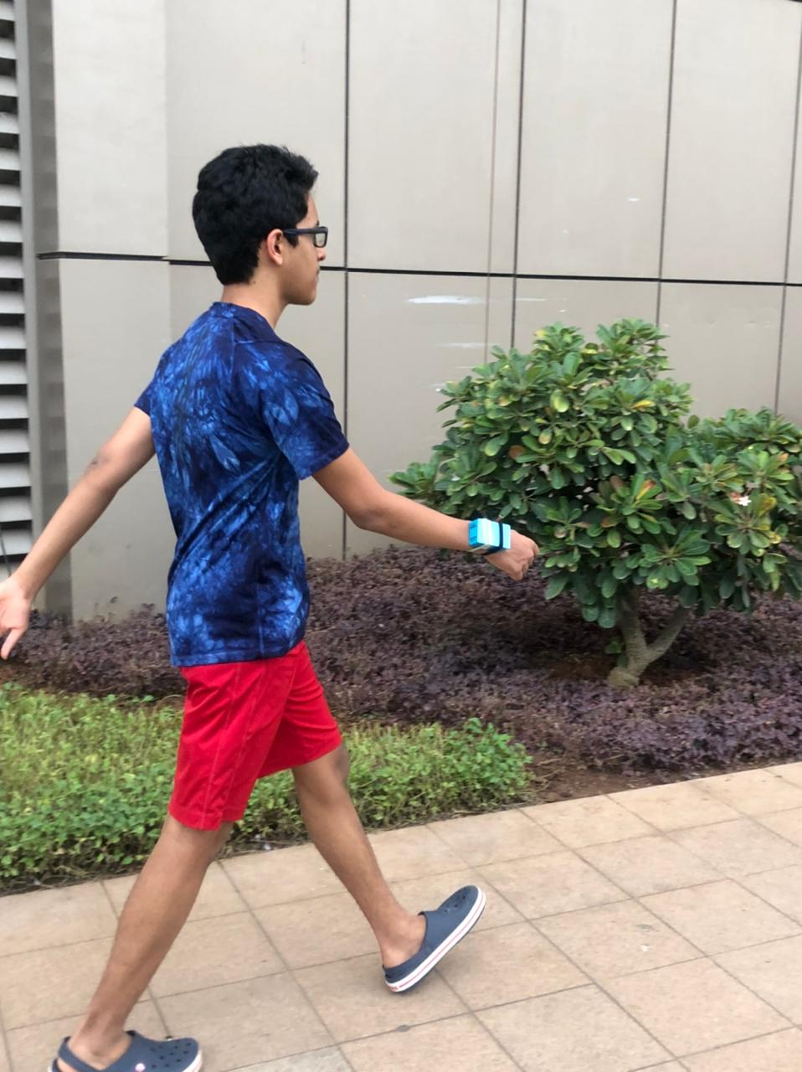

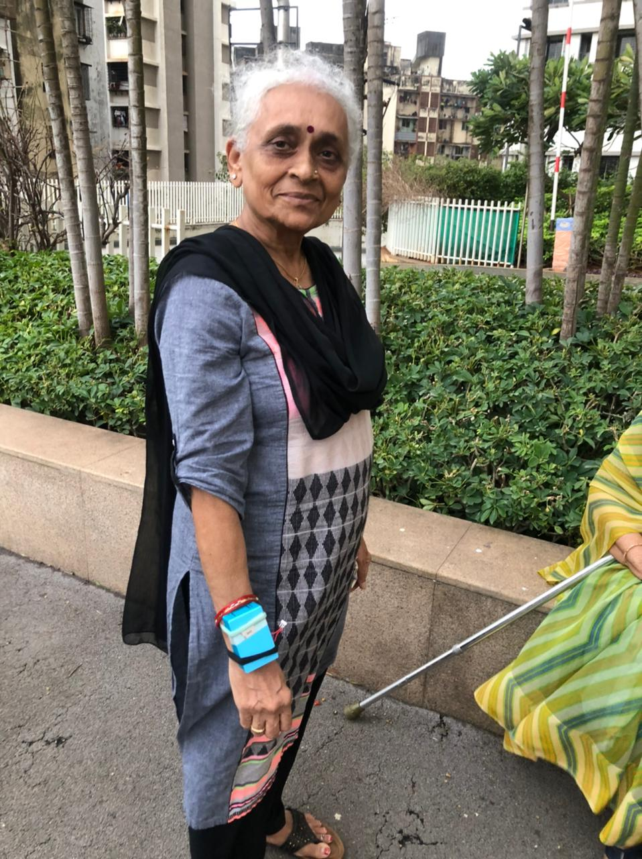

## Existing Solutions

## Smartwatches/Activity Trackers

## These activity trackers have multiple purposes and can be used to measure heart rate, steps and also have a screen which displays the time. These trackers are also linked to an app where the user can view their progress and data. These trackers are highly attuned in recording steps and heart rate accurately and presenting them in the smartphone application.

## These are ideal for those who are well aware of their goals and fitness requirements and can use the information provided by the tracker to best improve their health. Some smartwatches also have added abilities to message and even call others which may be considered a useful tool as well.

## The problem with these smartwatches, however is that the elderly do not need so much data and rather than helping them it is possible that these bands may confuse them further. While those who are relatively comfortable with technology can make good use of such products, the elderly may not be able to do so. This product also fails to address one of the key aims of our project which is to motivate them to exercise more. Our product includes a step goal to indicate progress and motivate the elderly to walk the designated number of steps. This is key in motivating them further. Additionally Saathi also provides the opportunity to meet new people and exercise together, another component which these trackers lack. Their multipurpose design also would make them expensive whereas Saathi’s relatively low cost can help it become for affordable and widespread.

## Amazon.com: Fitbit Charge 2 Heart Rate + Fitness Wristband, Black, Large (US Version), 1 Count: Health &amp; Personal Care

## Senior Exercise apps

## Other products with similar motives include exercise apps curated specifically for seniors. These apps usually are not accompanied with a device and have set workouts that the elderly can follow on a day to day basis.

## One such app, “Senior Fitness with Meredith,” has a selection of around 120 videos which are guides for exercise. These videos are useful for self-motivated seniors looking to try something new. To optimize their use of these apps, the seniors must be well aware of their health requirements and goals.

## The problem with these apps is that they rely on the self motivation of seniors whereas reports have shown that 73% of people who set exercise as their new year resolution dropped out before accomplishing their goal. In these non-interactive apps, motivation is likely to dwindle and that statistic is likely to be even higher. Additionally, when we interviewed seniors locally, we found that most of them were rather reluctant in trying a new form of exercise and would rather resort to an option they are more familiar with. As explained earlier, Saathi acts as a motivator and is more flexible than such apps which allow a greater proportion of seniors to benefit. Senior Fitness - Standing Balance Workout - YouTube

## Activity Tracking Apps

## Some smartphone apps also track steps and provide a cumulative report of your activity. These may also record data such as your food and water intake as well as sleep. These apps are particularly useful in data storage and are quite accurate in that regard. One such app, “Pacer” calculates your steps, distance, calories as well as time. Users can use this data to gauge their own progress and make adjustments accordingly. These apps are useful for seniors who require all that data but for many, it may become excessive. While they are generally accurate, the band we use also acts as a motivating factor and hence has an added benefit. These apps also miss the social aspect that we have found key in encouraging exercise and combating loneliness.

## 

**3. Our Solution(SAATHI)**

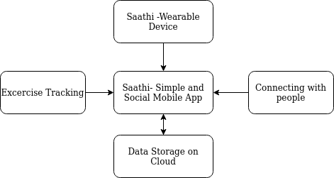

Our Solution , Saathi works on the principle of simplicity. it has 2 main parts -

1. Easy to use social fitness app - Saathi
2. Minimalist wearable band for exercise tracking

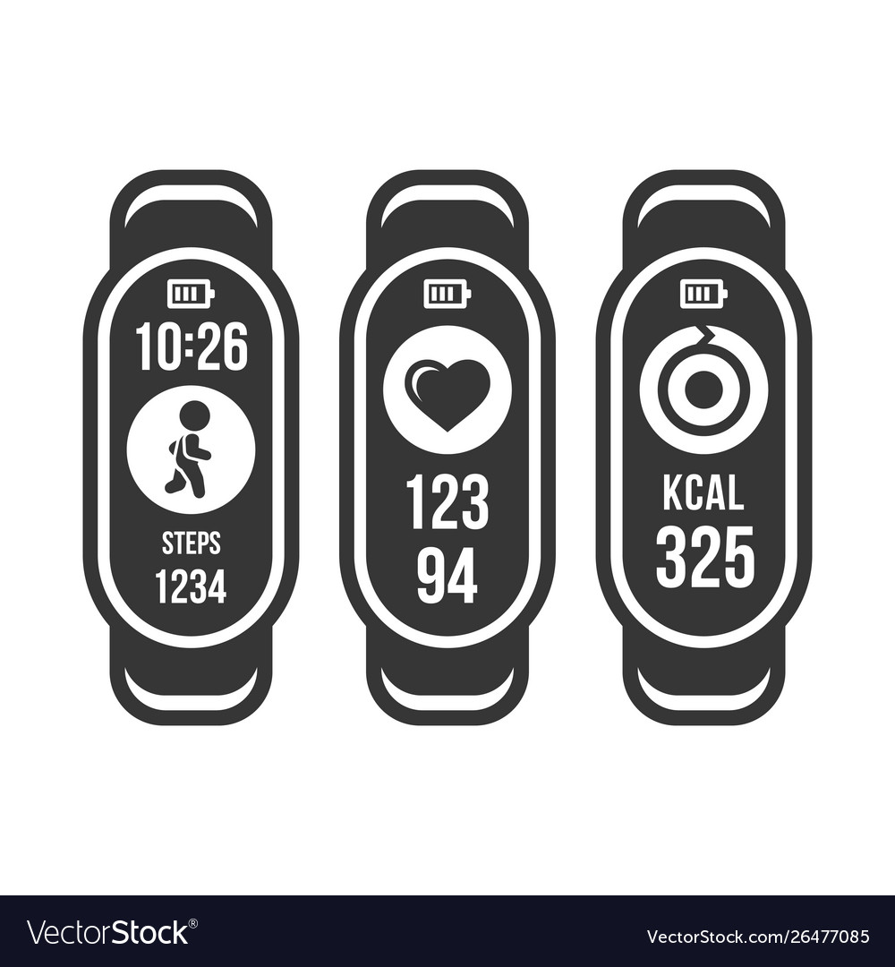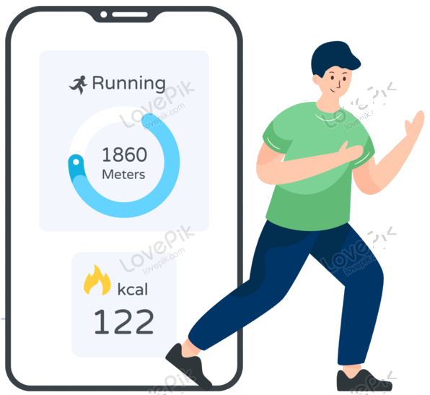

wearable device that is linked to an app. It is an easy way for the elderly to monitor their progress and meet other new people. The band can transfer the number of steps to the app and upon reaching a certain goal, change the colour of an LED to green, notifying the user simply. On the app, users have the opportunity to join a group to exercise with others in order to facilitate effective interaction and an opportunity to exercise with others as well.

This is in line with our goal to boost social interactions.

**The Band**

The overall goal of the band is to count a person’s steps with the help of an IMU sensor and when a set goal is achieved, light up a green LED light on the band to notify the person of the goal’s completion with ease. While it is on, the band can also connect to the app and data can be transmitted to it and received from it.

prototype-

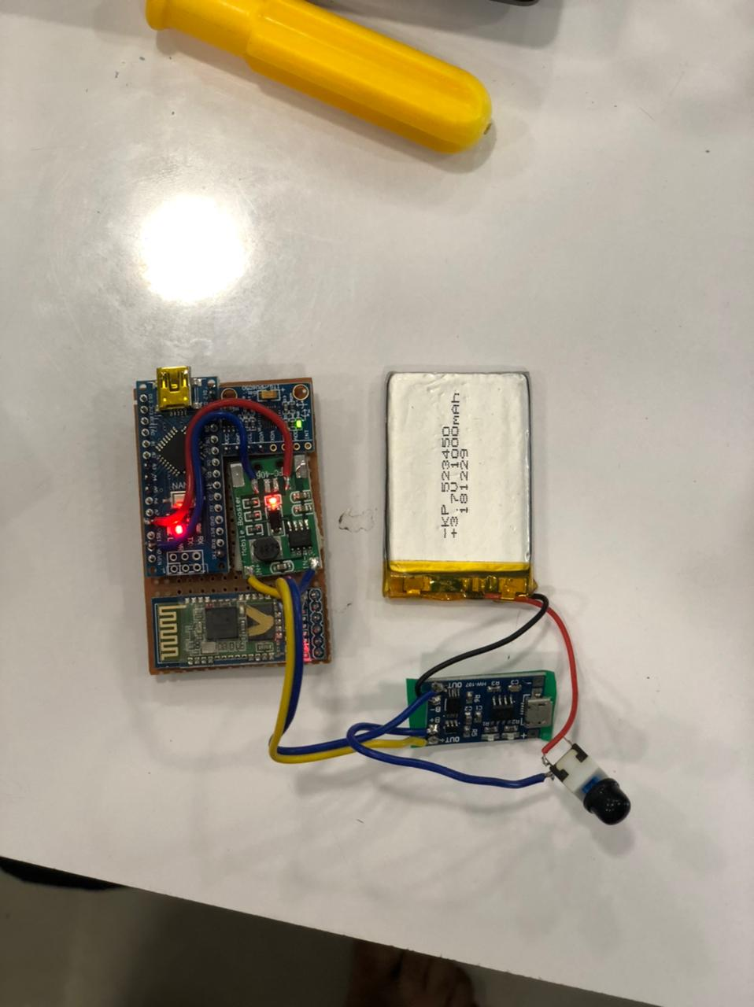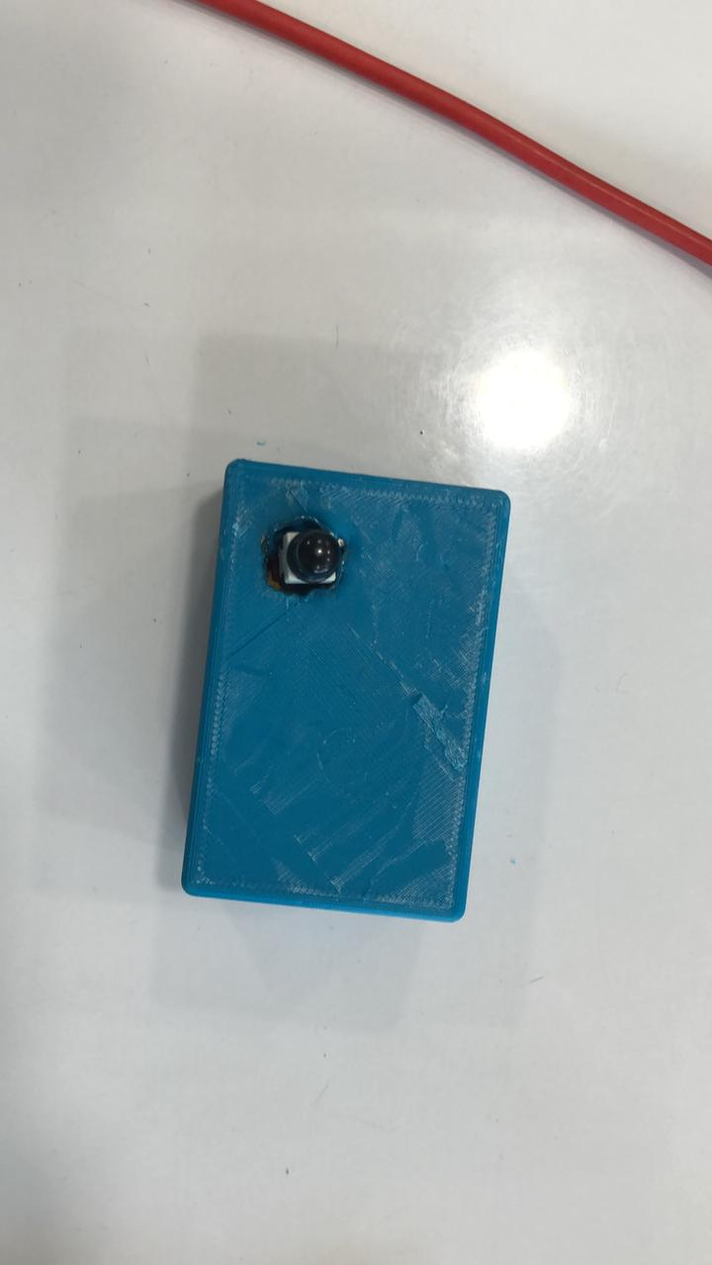

**Flow diagram of the Working of the device:**

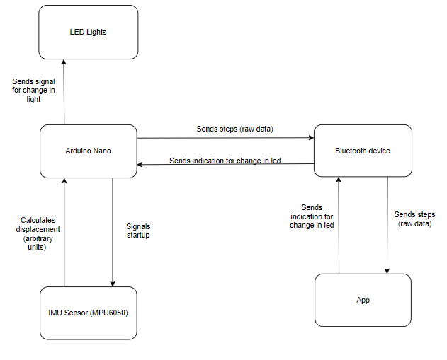

**CAD Design**

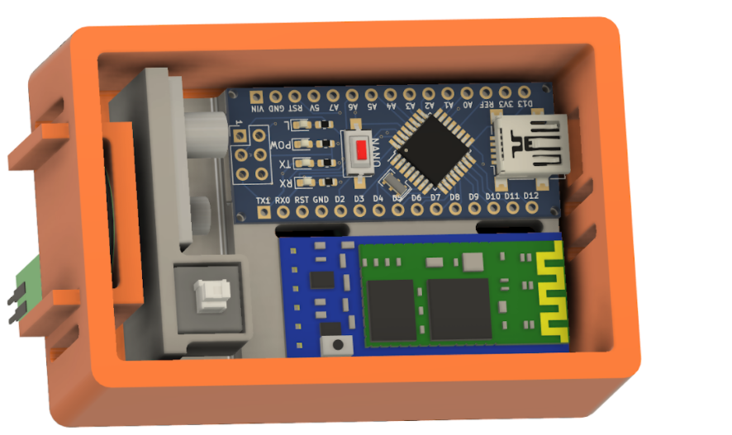

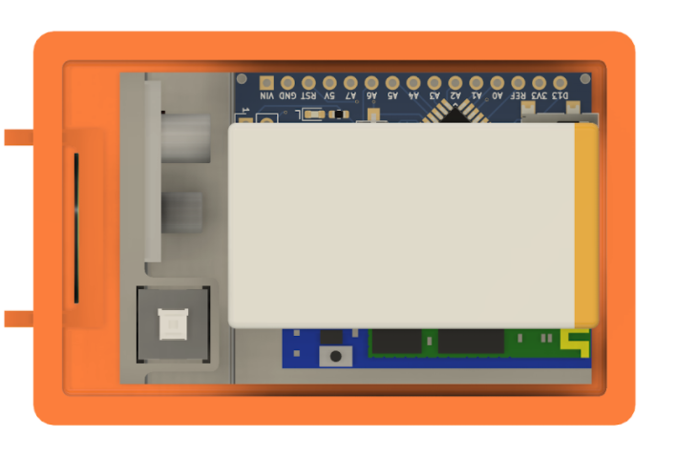

Here is a view of our CAD design for our prototype to see how the components were integrated within it.

**Dimensions**

Width= 4.5cm

Length= 6.9cm

Height=2.9cm

**Circuit Diagram**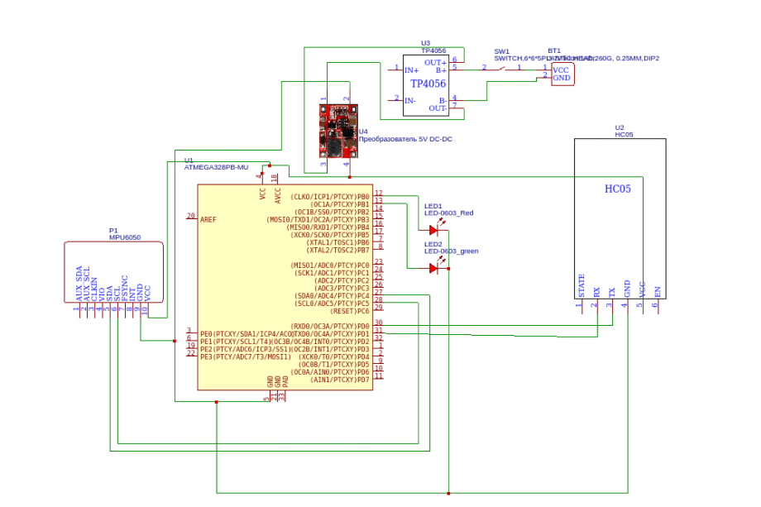

This is the circuit diagram for all the components that were used in our band and their connections.

We have used AtMega328p as the main microcontroller of the device and MPU6050 an the sensor to measure steps

MPU6050 connects with the microcontroller using I2C Protocol and sends raw data to the controller. Then the controller processes the data and calculates the step count, then it sends the data to the mobile application via bluetooth using software serial protocol with pin 11 and 12.

Another main part of the circuit is the power module. it has 3 main components-

1. 1000mAh li-ion battery
2. TP4056 Charging circuit
3. 3.7 to 5v Boost circuit

all three are connected to each other and provide consistent power to the device to work continuously.

**Component List**  
The parts used in the circuit are as follows:

***Arduino nano:*** Arduino nano is a smaller more concise version of the arduino uno. To maximise space for other facilities while still maintaining a small wristband we decided to use the arduino nano. Furthermore the arduino nano is breadboard friendly and provides a constant voltage. Arduino nano is also preferred in automation, circuits and robotics due to its low cost and small size.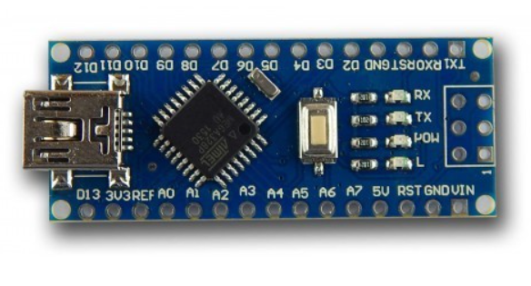

**Battery** - The battery powers the entire circuit.

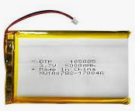

*Switch* - The switch allows the user to toggle the band on and off.

***IMU Sensor (MPU-6050)*** - The MPU6050 is a Micro Electro - mechanical system. It consists of an accelerometer and a gyroscope. Both have 3 axes (X, Y, Z).

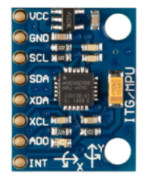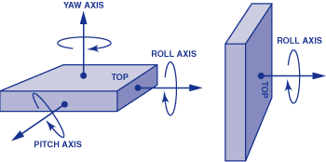

The gyroscope measures angular rotation along an axis. The accelerometer measures the vibration along each axis. The final output is as seen below:

**Algorithm**

We have used the Adafruit MPU 6050 library to take data from the IMU sensor and we have considered the z-axis data variation to calculate the count of steps. Then after that microcontroller directly sends the data to the mobile app via bluetooth using software serial and it also take step goal command from the app.

code to set the target value

*if(bt.available() > 0){*

*state = bt.read(); }*

*target = state.toInt();*

Code for step count

*if (g.gyro.z>1.25){*

*steps+=2;*

*bt.print(steps);*

*Serial.println(steps);*

*sf = true;*

*}*

*if (g.gyro.z<0.5){*

*sf=false;*

*}*

*if (steps>target){*

*digitalWrite(2, HIGH);*

*digitalWrite(3,LOW);*

*}// code to setup target*

*else{*

*digitalWrite(3, HIGH);*

*digitalWrite(2,LOW);*

*}*

*}*

**OUTPUT on serial monitor:**

These are the result that we got on the serial plotter and serial monitor respectively while testing the accuracy of the sensor.

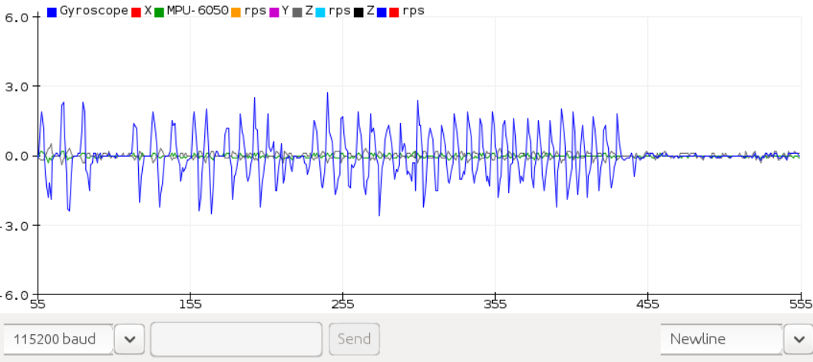

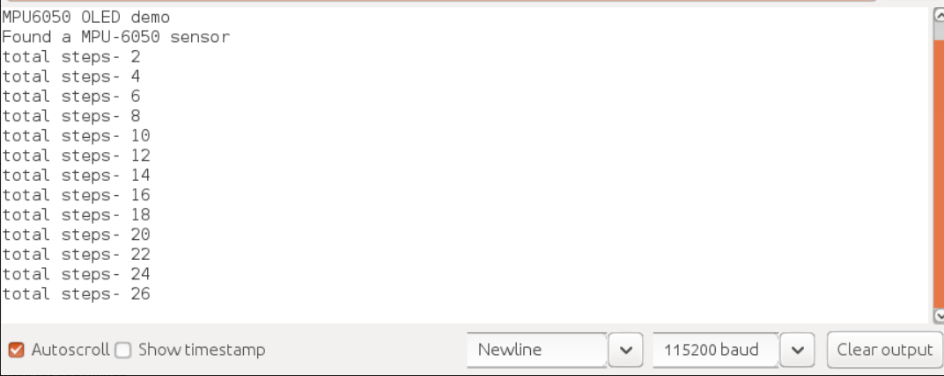

***Bluetooth Module (HC-05)*:** The bluetooth module is meant for short range wireless data communication. It facilitates easy interfacing between the arduino and the app. It is connected to the arduino via the Rx and Tx. The arduino sends data to the bluetooth module which is connected to the app.

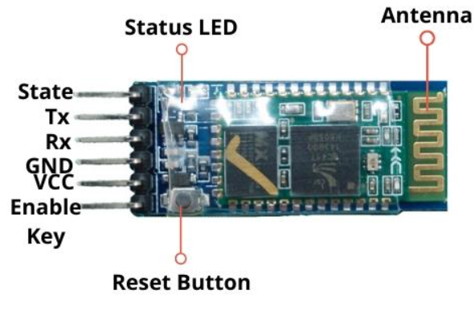

***DC to DC Micro-Booster (FC - 400)*:** The function of a micro-booster is to translate the incoming voltage from one level to another. In his case we were using a DC to DC Micro-Booster as we needed to increase our voltage up to 6 volts. We desoldered the usb port from the micro booster to allow connections from the 4 flat pins just underneath it.

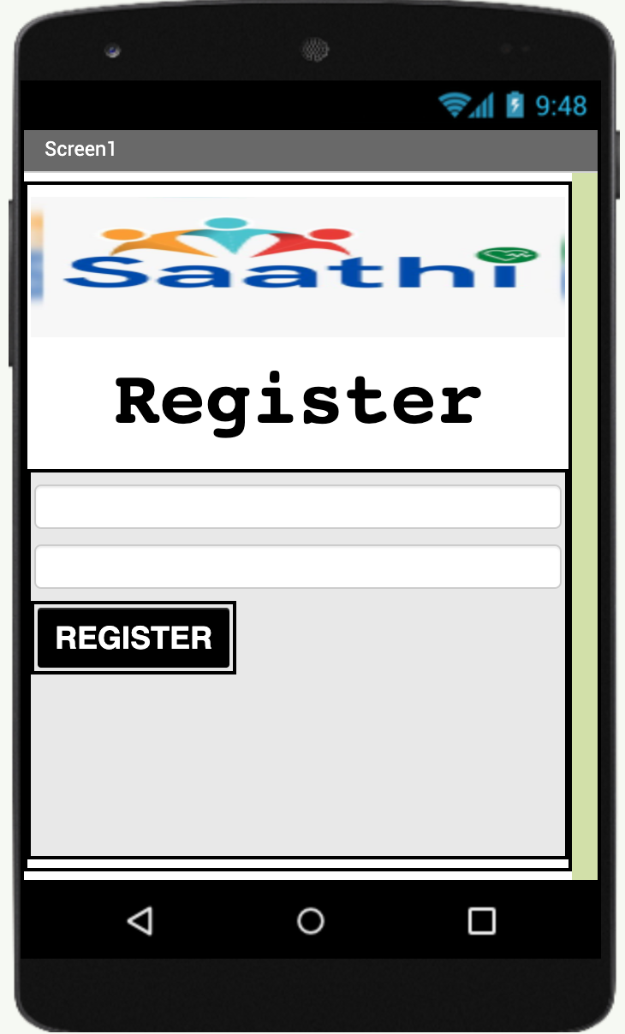

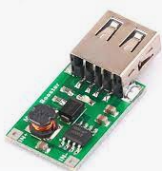

**Mobile app:**

**Description:**

The app consists of 4 main components: The registration(profiling) pages, home page, social page and profile page. The registration pages allow the users to make their own personalized account on which they will record their activities and work outs, we collect information such as the users name, date of birth, gender, height, weight and location, it is made with minimal buttons and options that could complicate the action of logging into an account for a user. The app is designed using **MIT App Inventor**.

**The home page:** consists of the general information that the app will provide the user with such as their step count, calories and distance traveled.

1. Profile screen
2. Login screen
3. Home screen
4. Social screen
5. Profile setup
6. **Introductory screen**: The introductory screen allows the user to login into his or her personal account, it asks for the username and password in order to maintain a certain level of privacy. So as 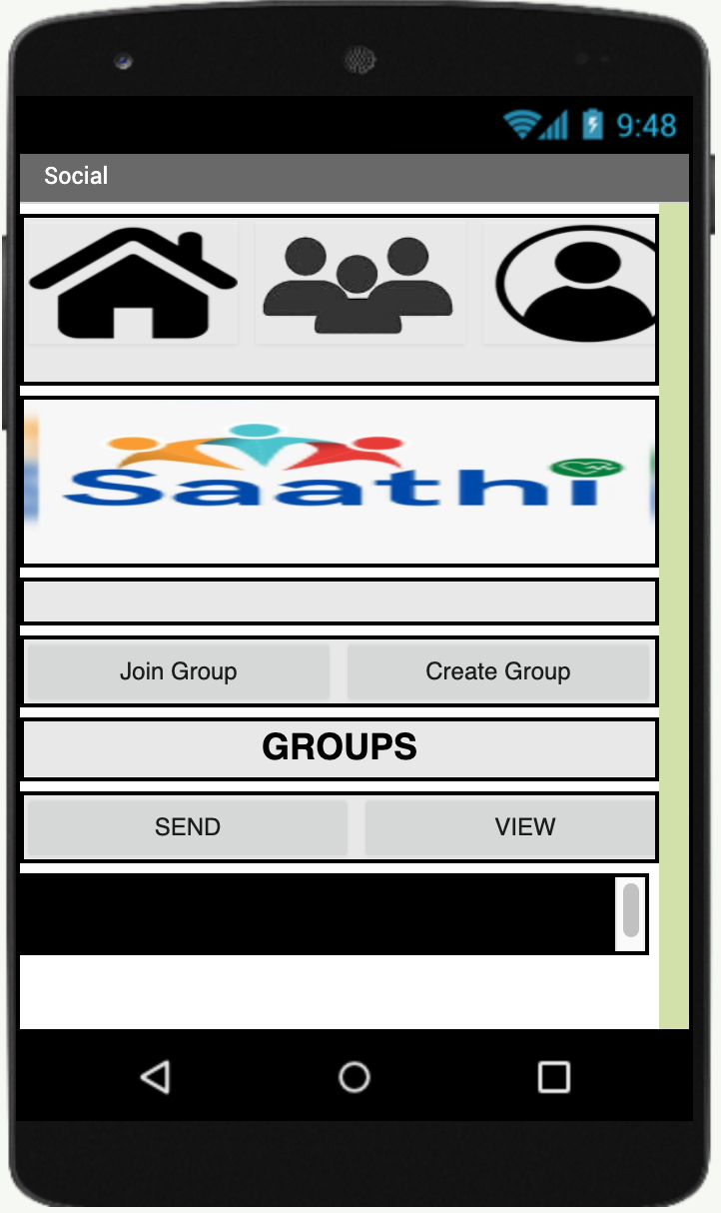to keep the experience as simple and effective as possible the screen consists of 4 parts: the logo, the box to enter the username, the box to enter the password and the button to confirm the information and login to the account.
7. **Home Page** : Every time a user wants to make a new entry in their app and account, they will be required to provide a step goal for the activity, we have given them this option in order to make their workouts more flexible and not very rigid, so that the user can alternate their goals according to their need and mood. This screen consists of a box for the user to enter the goal and a button to confirm the goal, this is done so that the users can carry out the action. without any extra, unnecessary information. The home page also displays the calories burnt and distance traveled.

Calories are calculated with the following formula:

steplength = height*0.208

steps per mile = 16000/steplength

2.02*0.57*body weight/steps per mile

1. **Groups getting formed:** The groups are formed on the social page, which is a page solely dedicated to the ‘community and group-based aspect of exercise’, it lets the user join workout groups whose purpose is to motivate them to exercise more along with their peers. The user will join 2 main groups, one of them will be more focused on them being more social and meeting their friends and family for a light workout and conversation. The other main type of group will be more focused on exercise and less conversation, which will result in very effective and complete workout experiences, which will result in maximum satisfaction for the user, we have also limited the number of groups an individual can join in order to give them a fixed number of choices so that they are not confused or overwhelmed by too many groups.
2. **Switching between groups**: As users become more experienced and advanced in their skills, they might want to move to a group that challenges their endurance, stamina and strength at a higher level, this is the reason why we will allow the users to leave and join new groups as they choose.
3. **Profile page**: Since the profiling and creating an account part of the app tends to be the most complicated part, we have strived to make it as simple, effective and streamlined as possible. We first ask the user to make a username and password, then we ask for their information that will allow them to store their progress on our app so that all the information is in one place and not separate. The profile screen is the area where the user 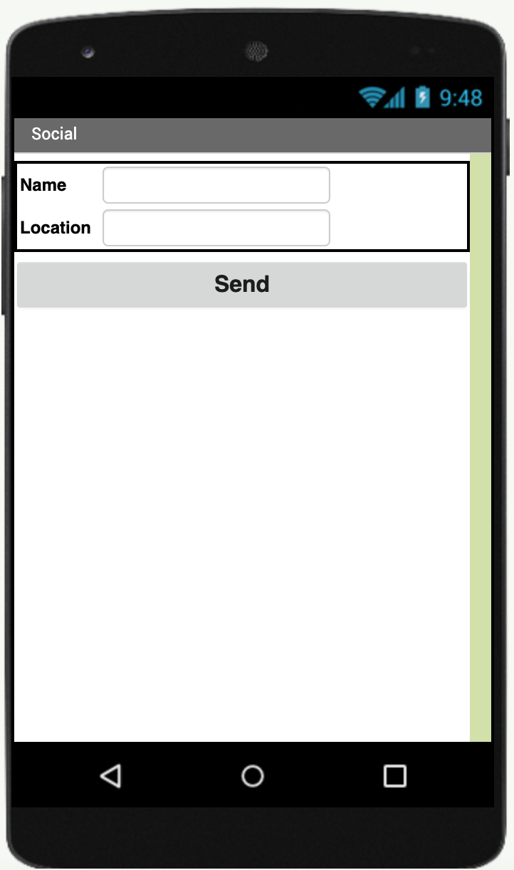can update and edit their information at regular intervals or as and when changes occur in the information provided

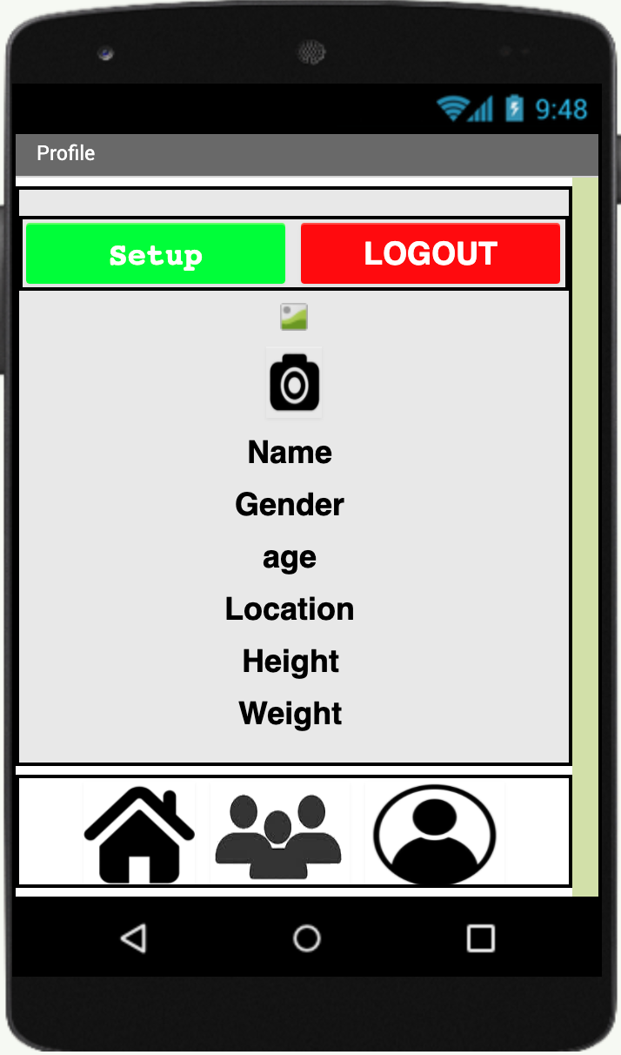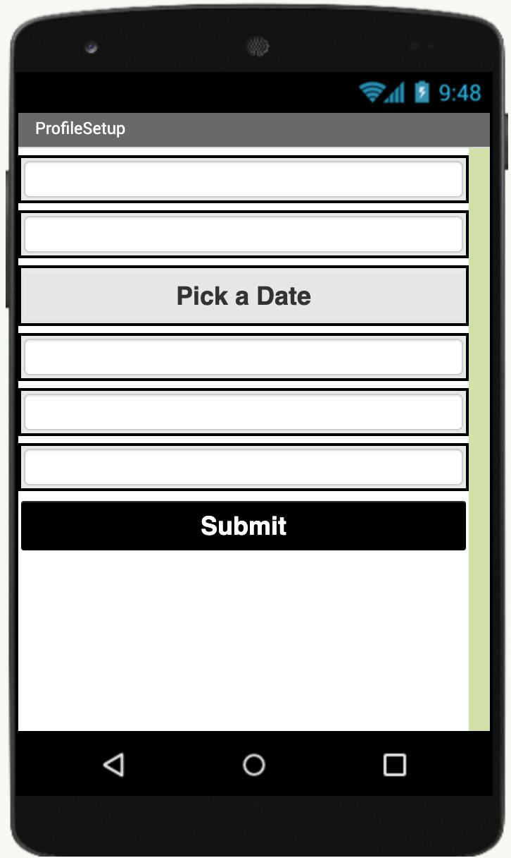

**Google Script Code**:

. This is used to obtain data from the app and post it into the google sheet. It has three primary functions:

1. doGet(e):

Gets data from the app with the variable e.

1. doPost(e) :

Posts the data onto the google sheet with variable e.

1. addUser(e,sheet):

This function adds a user profile by obtaining each piece of information from the app with variable e and posts it into the Google Sheet.

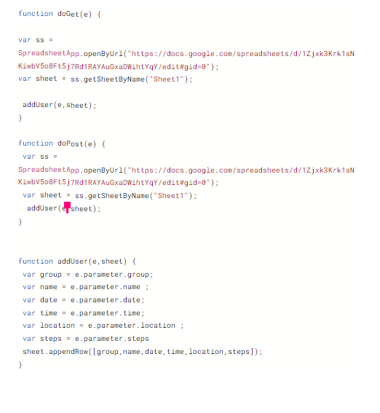

**Output on the drive**

| group | name | date | time | location | steps |
| --- | --- | --- | --- | --- | --- |
| group1 | Vikram | Jul 27, 2021 | 5:08:05 PM | mumbai | 0 |
| group1 | Ishaan | Jul 27, 2021 | 5:08:19 PM | mumbai | 0 |
| group2 | Rishne | Jul 28, 2021 | 5:59:40 PM | mumbai | 2 |
| group2 | Vibhav | Jul 28, 2021 | 6:12:41 PM | mumbai | 16 |
| group2 | Aadit | Jul 28, 2021 | 6:12:52 PM | mumbai | 36 |
| group2 | Neer | Jul 28, 2021 | 6:13:11 PM | mumbai | 62 |
| group2 | Vikram | Jul 28, 2021 | 6:21:52 PM | mumbai | 26 |

***Program Of the Device and Complications***

*---------------------------------------------------------------------*

*#include <Adafruit_MPU6050.h>*

*#include <Adafruit_SSD1306.h>*

*#include <Adafruit_Sensor.h>*

*#include "SoftwareSerial.h"*

*Adafruit_MPU6050 mpu;*

*Adafruit_SSD1306 display = Adafruit_SSD1306(128, 32, &Wire);*

*SoftwareSerial bt(11,12); //(rx,tx)*

*const int analogInPin = A0; // Analog input pin that the potentiometer is attached to*

*int sensorValue = 0; // value read from the pot*

*int steps = 0;*

*String state = "";*

*bool sf = false;*

*int target = 2000;*

*void setup() {*

*pinMode(2, OUTPUT);*

*pinMode(3, OUTPUT);*

*bt.begin(9600);*

*Serial.begin(115200);*

*// while (!Serial);*

*Serial.println("MPU6050 OLED demo");*

*if (!mpu.begin()) {*

*Serial.println("Sensor init failed");*

*while (1)*

*yield();*

*}*

*Serial.println("Found a MPU-6050 sensor");*

------------------------------------------------------------------

This is the first part of our code, and one of the main parts too. We import data from libraries and set up pin values for ports. We also initialize our gyroscopic accelerometer (MPU6050) and print an error message if initialization fails so we know that the problem is in our circuit and not the code.

*---------------------------------------------------------------------*

*if (sf==false){*

*if (g.gyro.z>1.25){*

*steps+=2;*

*bt.print(steps);*

*// bt.print("steps");*

*Serial.println(steps);*

*sf = true;*

*}*

*if (steps>target){*

*digitalWrite(2, HIGH);*

*digitalWrite(3,LOW);*

*}*

*else{*

*digitalWrite(3, HIGH);*

*digitalWrite(2,LOW);*

*}*

*}*

*if (g.gyro.z<0.5){*

*sf=false;*

*}*

*----------------------------------------------------------------------*

This is the second, latter part of our arduino code. As seen we take data from the serial plotter, we check whether that value is greater than 1.25. We chose this number through testing how sensitive the IMU sensor is. We realized that we move our hands forward greater than we move it backwards so we chose to take only the forward reading and added 2 steps every time the above condition is fulfilled. After that we have code that checks whether our ‘target’ variable has been crossed or not. If it has we turn the green led light on, ‘high’, or else we turn the red led on, ‘high’, and the green led off , ‘low.’

1. **Future Scope:**

There is a range of improvements that could be made in the future since this is just a prototype. For starters, we hope to incorporate a heart rate sensor which would keep an accurate record of the heart rate as our readings were not too accurate. This could also allow us to build in a safety feature to notify the person if it went too high or low. We attempted using an Spo2 sensor for this measurement but found that readings were far too inaccurate on the wrist to make sense of. The noise rendered the data almost useless. While the Spo2 sensor was quite accurate on the finger, this would require an external attachment which would have to stick out from the device and hence we choose not to include it in our product. Yet, it is a useful feature and would be a significant improvement.Furthermore, we would aim to integrate a range of features into the app such as a refined system of dynamic goal setting based on their personal information as well as dynamic group recommendations based on location, level of activity and health profile. In addition, for the social page, we intend to make it so that people can chat with one another and set common exercise times at which a red LED could light up on the band. Lastly, we are looking to optimise the band so it is smaller in size and will be comfortable to wear and is not too intrusive and ensure the app can send necessary notifications.

1. **Conclusion:**

The device and app have been tested extensively on fellow team members. We have found that the code is highly accurate and usually an accuracy of 95%. The goal setting algorithm also works well and can be used to track progress and also to update your target. Our app stores all data in sheets to access later, add more features on the app and do research related to the problems seniors face. Past data is visible and by joining a group, one can view others data as well. We firmly believe that this app can revolutionise fitness for the elderly and drastically improve their physical and mental health.

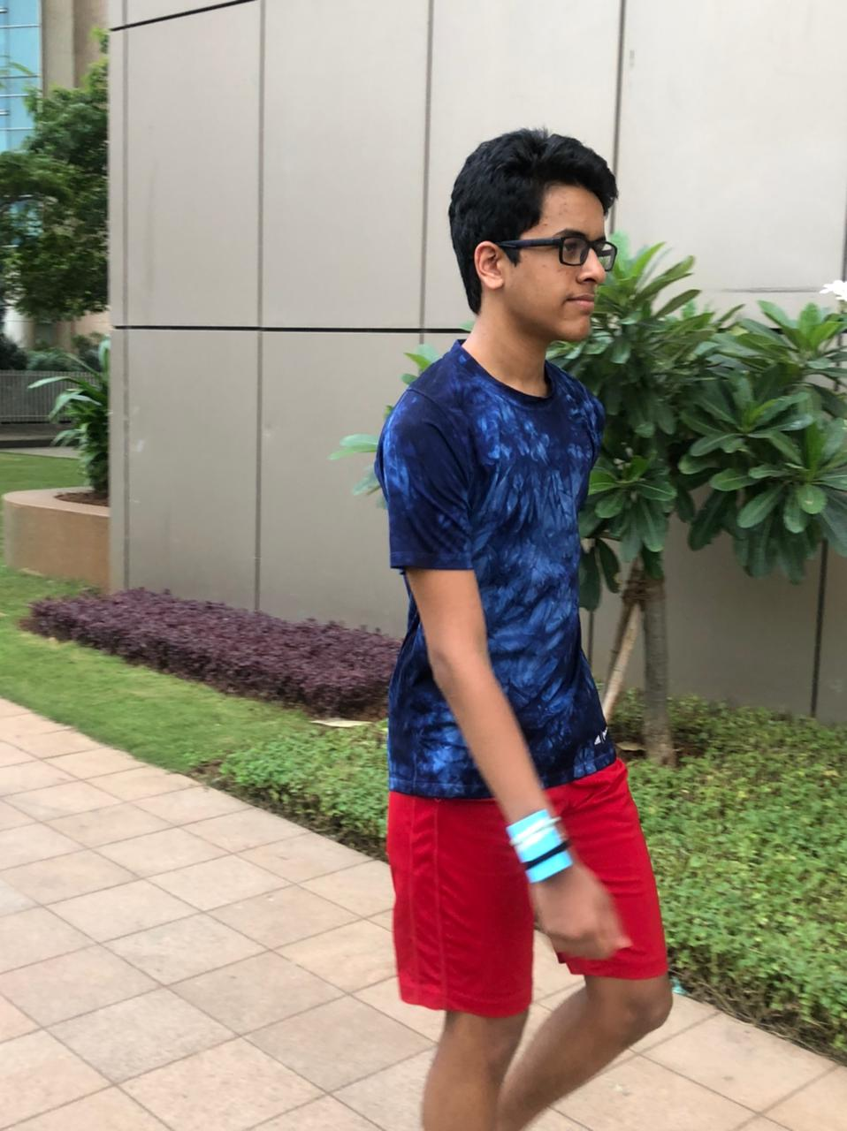

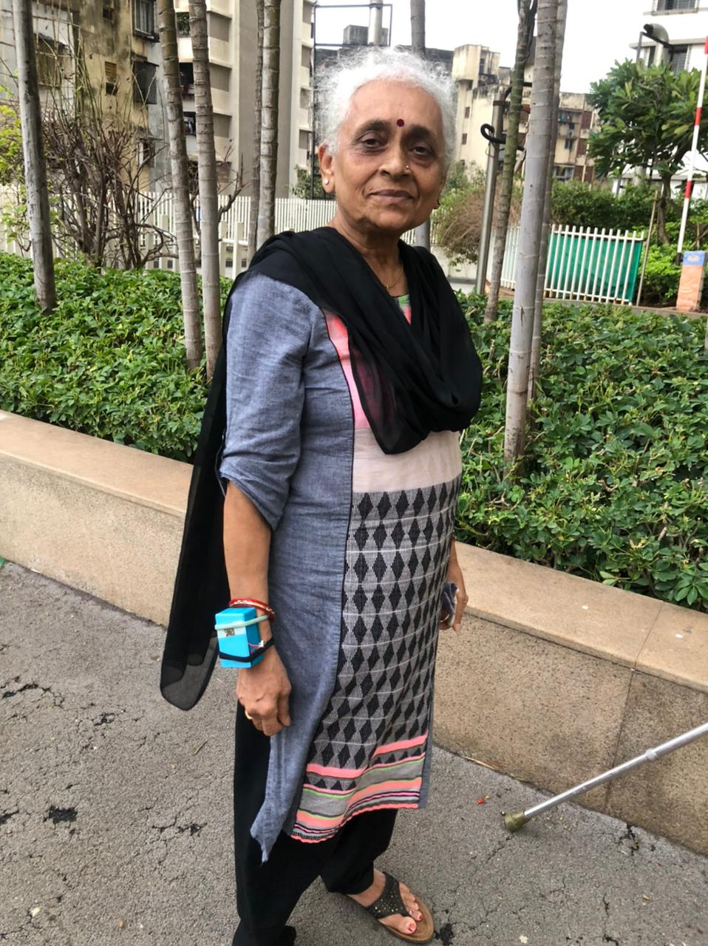

**REFERENCES**

1)CASSILHAS, RICARDO C., et al. “The Impact of Resistance Exercise on the Cognitive Function of the Elderly.” Medicine & Science in Sports & Exercise, vol. 39, no. 8, 2007, pp. 1401–07. Crossref, doi:10.1249/mss.0b013e318060111f.

2)Corrêa Dias, Rosângela, et al. “Impact of an Exercise and Walking Protocol on Quality of Life for Elderly People with OA of the Knee.” *Physiotherapy Research International*, vol. 8, no. 3, 2003, pp. 121–30. *Crossref*, doi:10.1002/pri.280.

3)Isolation, N. (2021, July 16). *Why do many seniors have trouble using technology?* No Isolation. <https://www.noisolation.com/research/why-do-many-seniors-have-trouble-using-technology/>

4)Rey, S. (2020, May 1). *Procrastination, demotivation and loneliness - how you can get through it!* ShireWomen. https://shirewomen.com.au/blogs/business/procrastination-demotivation-and-loneliness-how-you-can-get-through-it#:%7E:text=There%20are%20certain%20factors%20that,and%20the%20inability%20to%20achieve

5)*What to Know About Living Alone After 60*. (2021, March 25). WebMD. https://www.webmd.com/healthy-aging/what-to-know-about-living-alone-after-60#1

6)Wu, B. (2020, June 5). *Social isolation and loneliness among older adults in the context of COVID-19: a global challenge*. Global Health Research and Policy. https://ghrp.biomedcentral.com/articles/10.1186/s41256-020-00154-3

*7)Health Risks of an Inactive Lifestyle*. (2021, May 5). Medline Plus. <https://medlineplus.gov/healthrisksofaninactivelifestyle.html>

8) Langhammer, Birgitta, et al. “The Importance of Physical Activity Exercise among Older People.” *BioMed Research International*, vol. 2018, 2018, pp. 1–3. *Crossref*, doi:10.1155/2018/7856823.

9)Daly, Michael, et al. “A Bidirectional Relationship between Physical Activity and Executive Function in Older Adults.” *Frontiers in Human Neuroscience*, vol. 8, 2015. *Crossref*, doi:10.3389/fnhum.2014.01044.

10) Sjölund, Britt-Marie, et al. “Incidence of ADL Disability in Older Persons, Physical Activities as a Protective Factor and the Need for Informal and Formal Care – Results from the SNAC-N Project.” *PLOS ONE*, edited by Pasquale Abete, vol. 10, no. 9, 2015, p. e0138901. *Crossref*, doi:10.1371/journal.pone.0138901.